**EE 463 Static Power Conversion-1**

**Hardware Project**

**Final Design Report**

**Civan Serhat Çevik Yusuf Toprak Yıldıran Batuhan Elmas**

**2442770**   **2444149**  **2516086**

**Table of Contents**

1. Introduction 3

2. Topology Selection 3

3. Component Selection 3

4. Loss Calculations 5

5. Detailed Simulation 7

6. Controller Simulation and Design 12

6.a Controller Simulation 13

6.b Controller Design for PCB 15

7. PCB Design 16

8 . Bills of Material 21

9 . Conclusion 22

## Introduction

The objective of this project is to design and implement a controlled rectifier to drive a DC motor effectively. The rectifier will be capable of accepting either single-phase or three-phase AC input from the grid and will provide a variable DC output via a variac. The maximum specified output voltage of the rectifier is 180 V, with the voltage adjustable to meet the operating requirements of the motor. This report outlines the details of the project. First, we describe the selected topology and the components chosen for implementation. Next, we calculate the losses associated with the selected components. Following this, a simulation environment will be developed to account for the nonidealities of the components. Using this simulation, we will design a PI controller for motor speed control, applicable both in the simulation environment and in real-world implementation. Finally, we will present a detailed PCB design for the circuit, including all necessary specifications.

## Topology Selection

A Three-Phase Diode Rectifier converts three-phase AC power into unregulated DC power using six diodes arranged in a bridge configuration. The diodes conduct alternately, depending on the phase voltages, to produce a pulsating DC output with lower ripple compared to single-phase rectifiers. In this topology our average output voltage will be the voltage we get from the rectifier multiplied by the duty cycle (D).

We made comparisons between single phase and three phase diode rectifiers. The first of these comparisons was the ripple comparison, three-phase rectifiers produce lower ripples in the DC output due to more frequent conduction intervals (6 pulses per cycle) compared to single-phase rectifiers (2 pulses per cycle). Also, three phase ripple voltage is smaller than single phase. This makes the output of three-phase rectifiers smoother and less dependent on large filtering components. Other comparison we talked about is harmonics, A Single-Phase Diode Rectifier introduces lower-order harmonics (e.g., the 3rd, 5th, etc.) into the AC supply, which can distort the supply waveform and lead to higher levels of Total Harmonic Distortion (THD). In contrast, a Three-Phase Diode Rectifier generates higher-order harmonics (e.g., the 5th, 7th, etc.), which are less impactful on the system and easier to filter, resulting in lower overall THD. In summary, we decided to choose the **Three Phase Diode Rectifier + Buck Converter** since it provides a simple solution and is cheaper compared to other topologies. Moreover, it is straightforward to implement, provides adjustable DC output, and has relatively low ripple on the DC bus. In the following sections, the simulation of the topology we selected, its calculations and the selection of components to be used for the circuits are given.

## Component Selection

1. **Buck Converter Switch**

The buck converter is crucial for energy conversion, with MOSFETs and IGBTs being key components for efficient switching. MOSFETs excel in high-frequency applications due to their fast switching and field-controlled operation but are limited in voltage ratings. IGBTs, like the IXGH30N60C2 with a 600V rating, offer better voltage handling and lower conduction losses at high voltages, suitable for our needs despite a maximum 285V observed. While our simulations peak at 23A, the IXGH30N60C2’s 30A rating and comparable switching performance to the IXGH24N60C4D1 make it ideal, ensuring safety and performance alignment with our requirements.

**Table 3.1: IXGH24N60C4D1 vs. IXGH30N60C2**

|  |  |  |
| --- | --- | --- |
| Maximum Ratings | IXGH24N60C4D1 | IXGH30N60C2 |
| Collector-Emitter Voltage (VCEmax) | 600 V (@ TJ=150 °C) | 600 V (@ TJ=150 °C) |
| Collector Current (ICmax) | 24 A (@ TJ=110 °C) | 30 A (@ TJ=110 °C) |
| Gate Charge (Qg) | 64 nC (@ Ic=24A) | 70 nC (@ Ic=30A) |
| Turn-On Delay Time (tDon) | 21 ns (@ TJ=125 °C) | 13 ns (@ TJ=125 °C) |
| Turn-Off Delay Time (tDoff) | 143 ns (@ TJ=125 °C) | 120 ns (@ TJ=125 °C) |

As we can see in the table, IXGH30N60C2 shows that it is more effective in terms of maximum collector current, opening and closing time, which proves our choice.

**b. Buck Converter Freewheeling Diode**

The freewheeling diode is critical in the buck converter, providing a current path when the switch is off. It must block up to 285V reverse voltage and handle a peak current of 20A. We chose the DSEI30-06A power diode for its 600V breakdown voltage, 37A current capacity, and short recovery time, making it suitable for high-frequency operation in the 1-3 kHz range and ensuring reliable performance under our rated conditions.

**Table 3.2: DSEI30-06A Parameters**

|  |  |
| --- | --- |
| Parameters | Maximum Ratings |
| Forward Current (IF) | 37 A (@ TJ=85 °C) |
| Reverse Blocking Voltage (VR) | 600 V (@ TJ=125 °C) |
| Reverse Recovery Time (trr) | 1. s (@ IF = 30 A ) |

1. **Rectifier Output Capacitors**

Combining film and electrolytic capacitors at the output of a rectifier provides benefits that improve output voltage stability and power efficiency. Film capacitors great at filtering high-frequency noise due to their low ESR and ESL, making them ideal for suppressing switching noise and ripple. In contrast, electrolytic capacitors, since they have high capacitance per unit volume, they effectively handle low-frequency ripple, in the range of 300 Hz ripple generated by rectified AC. This combination also enhances ripple current handling and reliability. While electrolytic capacitors can manage large ripple currents, they tend to overheat or degrade during long term high-frequency stress. Since film capacitors have low ESR, they can supply instant current demand ,and manage high-frequency ripple current, reducing heat generation and extending the life of the electrolytics. Moreover, the parallel configuration results in lower ESR minimizing power dissipation.

**Table 3.3: C4AEGBW6100A3NJ Film Capacitor Parameters**

|  |  |
| --- | --- |
| Parameters | Ratings |
| Cap Value | 100uF |
| ESL | 35 nH |
| ESR | 3 mΩ |
| dV/dt | 4 (V/μs) |
| Ipkr(pk repetitive current) | 442 A (peak) |
| Irms | 19 A(rms) |
| Rth | 12 (°C/W) |

**Table 3.4: B43547A9107M000 electrolyte Capacitor Parameters**

|  |  |
| --- | --- |
| Parameters | Ratings |
| Cap Value | 100uF |
| ESR | 170 mΩ |

Lastly, using the NCD57085DR2G gate driver provides us with internal galvanic isolation, so we do not need to use an external optocoupler to isolate the microcontroller. Its compact structure allows us a power efficient operation with low power loss. Gate resistance is selected according to the datasheet of the gate driver as 5 ohms. It’s important to use it to decrease di/dt and EMI problems and improve EMC. Also, please note that microcontroller and current sensor components selections are mentioned in the controller design section.

## Loss Calculations

To calculate the losses, we first did research on which types of components cause which types of losses and as a result, we found that most of the losses in the system were caused by the 3-phase bridge rectifier, IGBT and freewheeling diode. Then we found out what types of losses there were in these components and how to calculate these losses.

**Losses for diode rectifier (VUO36-16NO8)**

Conduction Losses:

To obtain the **If (Forward Current = 10A)** value, we looked at the rectifier current graph and obtained the **Vf (Forward Voltage Drop = 1.05 V**) value from the rectifier datasheet according to the current value we obtained from here. We made a calculation for **D (Duty Ratio=0.8)** according to the desired voltage value at the output, as we mentioned in the previous pages.

**Losses for IGBT (IXGH30N60C2)**

Conduction Losses:

To find the conduction loss of the IGBT, we accessed the **r (slope resistance=0.02 Ω)** value from the datasheet, then looked at the current waveform graph and obtained the average **output current value (Io = 23A)**.

Switching Losses:

To find the switching loss value of the IGBT, we first obtained the **Vin (input voltage=230V)** value, this value is actually equivalent to the output voltage of the rectifier and to find this value, we looked at the voltage graph of the IGBT, we did the same for **Io (output current= 23A)**, we looked at the current graph of the IGBT and got approximate values from there. For the **switching frequency (fsw = 3.5kHz)**, we applied the operations explained in the duty ratio. For the **tr (rise time = 17ns)** and **tf (fall time=130ns)** values, we looked at the IGBT datasheet.

**Losses for freewheeling diode (DSEI30-06A)**

Conduction Losses:

To obtain the **If (Forward Current=23A)** value, we looked at the freewheeling diode current graph and obtained the **Vf (Forward Voltage Drop=1.3V)** value from the freewheeling diode datasheet according to the current value we obtained from here. Also, we use same D values for all system.

Switching Losses:

For the calculation of freewheeling diode switching loss, we looked at the freewheeling diode datasheet for **Vrr(repetitive reverse blocking voltage=600V)**, **trr  (reverse recovery time=150ns)**and **Ir (reverse current = 100µA)** values. We took the D and fsw values as mentioned above.

After calculating all power loss values, we obtained our approximate total loss sourced from these components. These losses can be used in thermal analysis and efficiency calculations in further analysis.

## Detailed Simulation

After the component selections, a detailed simulation is conducted for predicting the realistic anomalies caused by the nonidealities of the components during the operation. While doing this simulation, we entered the some parameters by referencing the datasheets for each component in order to be close to the data we would obtain in real life. In addition to these, to obtain a result similar to real life, we have included some parasitic elements into the simulations, such as line inductances and parasitic capacitances that are in the pcb layout. While doing the detailed simulation, we chose Simulink as the simulation environment because all the components we used were present and sufficient parameters affecting the losses could be entered into these components. In addition, it provides sufficient opportunities for the controller we will design, allowing us to make a realistic controller design without making an additional topology configuration.

We added parasitic elements so that the simulation was suitable for real life. One of these parasitic elements was the parasitic inductance originating from the PCB. Parasitic inductance in PCBs arises from the inherent inductive properties of conductors and the PCB layout. This inductance can interfere with signal integrity, create electromagnetic interference (EMI), and degrade circuit performance. There are some parameters that increase and decrease the parasitic inductance, and while designing the PCB, we took these concepts into consideration and shaped our design accordingly. One of these is the trace geometry of PCB, the thickness, width and length of the trace are the properties that affect parasitic inductance. For example, if we increase the width of the trace, we will decrease the inductance because of a larger cross-sectional area, however; if we increase the length of the trace, we will get higher inductance as inductance increases linearly with length.

Another feature that affects parasitic inductance is the location of the traces relative to the ground plane. Traces closer to the ground plane exhibit reduced parasitic inductance due to better coupling with the return path. Also, the inductance is inversely proportional to the height of the trace above the ground plane. When estimating parasitic inductances, we used the graph in Figure 5.1 obtained from the "Altium" website.

Figure 5.1: Output Impedance vs Frequency Graph for PCB

From the graph, we found the point where the frequency we were working with intersected the graph, then we determined an approximate value according to our working voltage and as a result, Lpar= 100nH

In the nonideal simulation case, it is observed that current passing through the diode has some ringing problem that may cause EMI problem and may cause the MOSFET to turn by mistake. The reason for the damped oscillations in Figure 5.3, is the resonance between parasitic line inductances and the parasitic diode capacitances and it is not observed in the simulation with ideal components since there were no parasitic inductances and nonideal parameters of the components. If this phenomena would create a problem and it can not be solved by layout optimization, some additional precautions may be taken. These may be adding a snubber circuit to supress the high di/dt noise, or increasing the 5ohm gate resistances of the MOSFET to 6-10ohm to damp the noise interfered by the gate netlines. If larger value resistors are used with the same package size, only the resistors can be replaced without needing to redesigning the layout. Furthermore, rectifier output voltage ripple is increased due to ESR value of the output capacitor. It is seen that the voltage and current waveforms of the rectifier and flyback diodes and the MOSFET are as follows in the Figure 5.4 to Figure 5.10, and there is nothing unusual to be detected.



*Figure 5.2 : IDEAL CASE Diode Current vs Time in Rectifier Circuit*

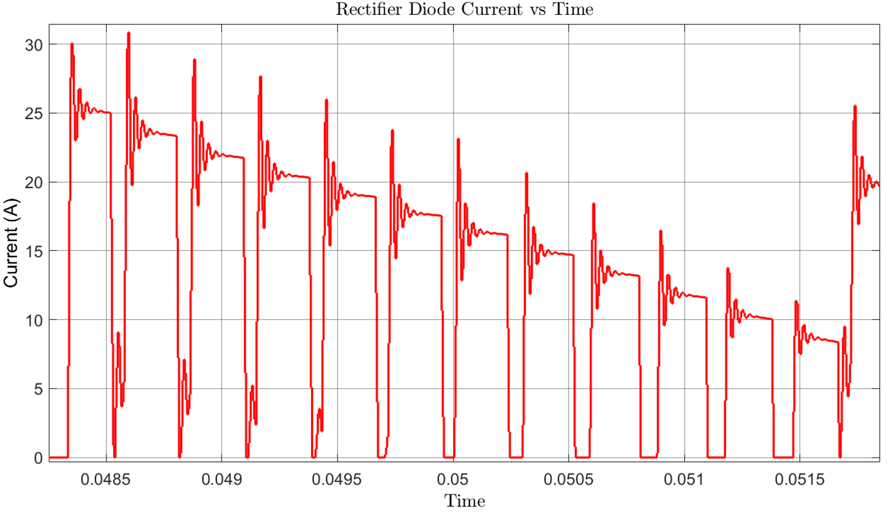

*Figure 5.3 : NONIDEAL CASE Diode Current vs Time in Rectifier Circuit*

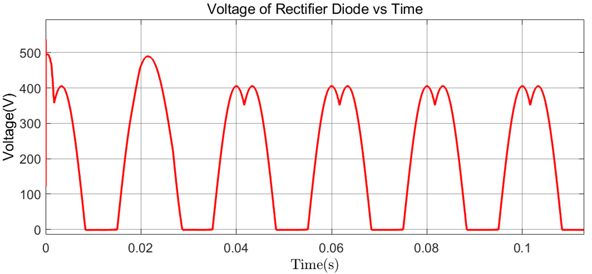

*Figure 5.4 : NONIDEAL CASE Diode Voltage vs Time in Rectifier Circuit*



*Figure 5.5 : IDEAL CASE Rectifier Circuit Output Voltage vs Time*

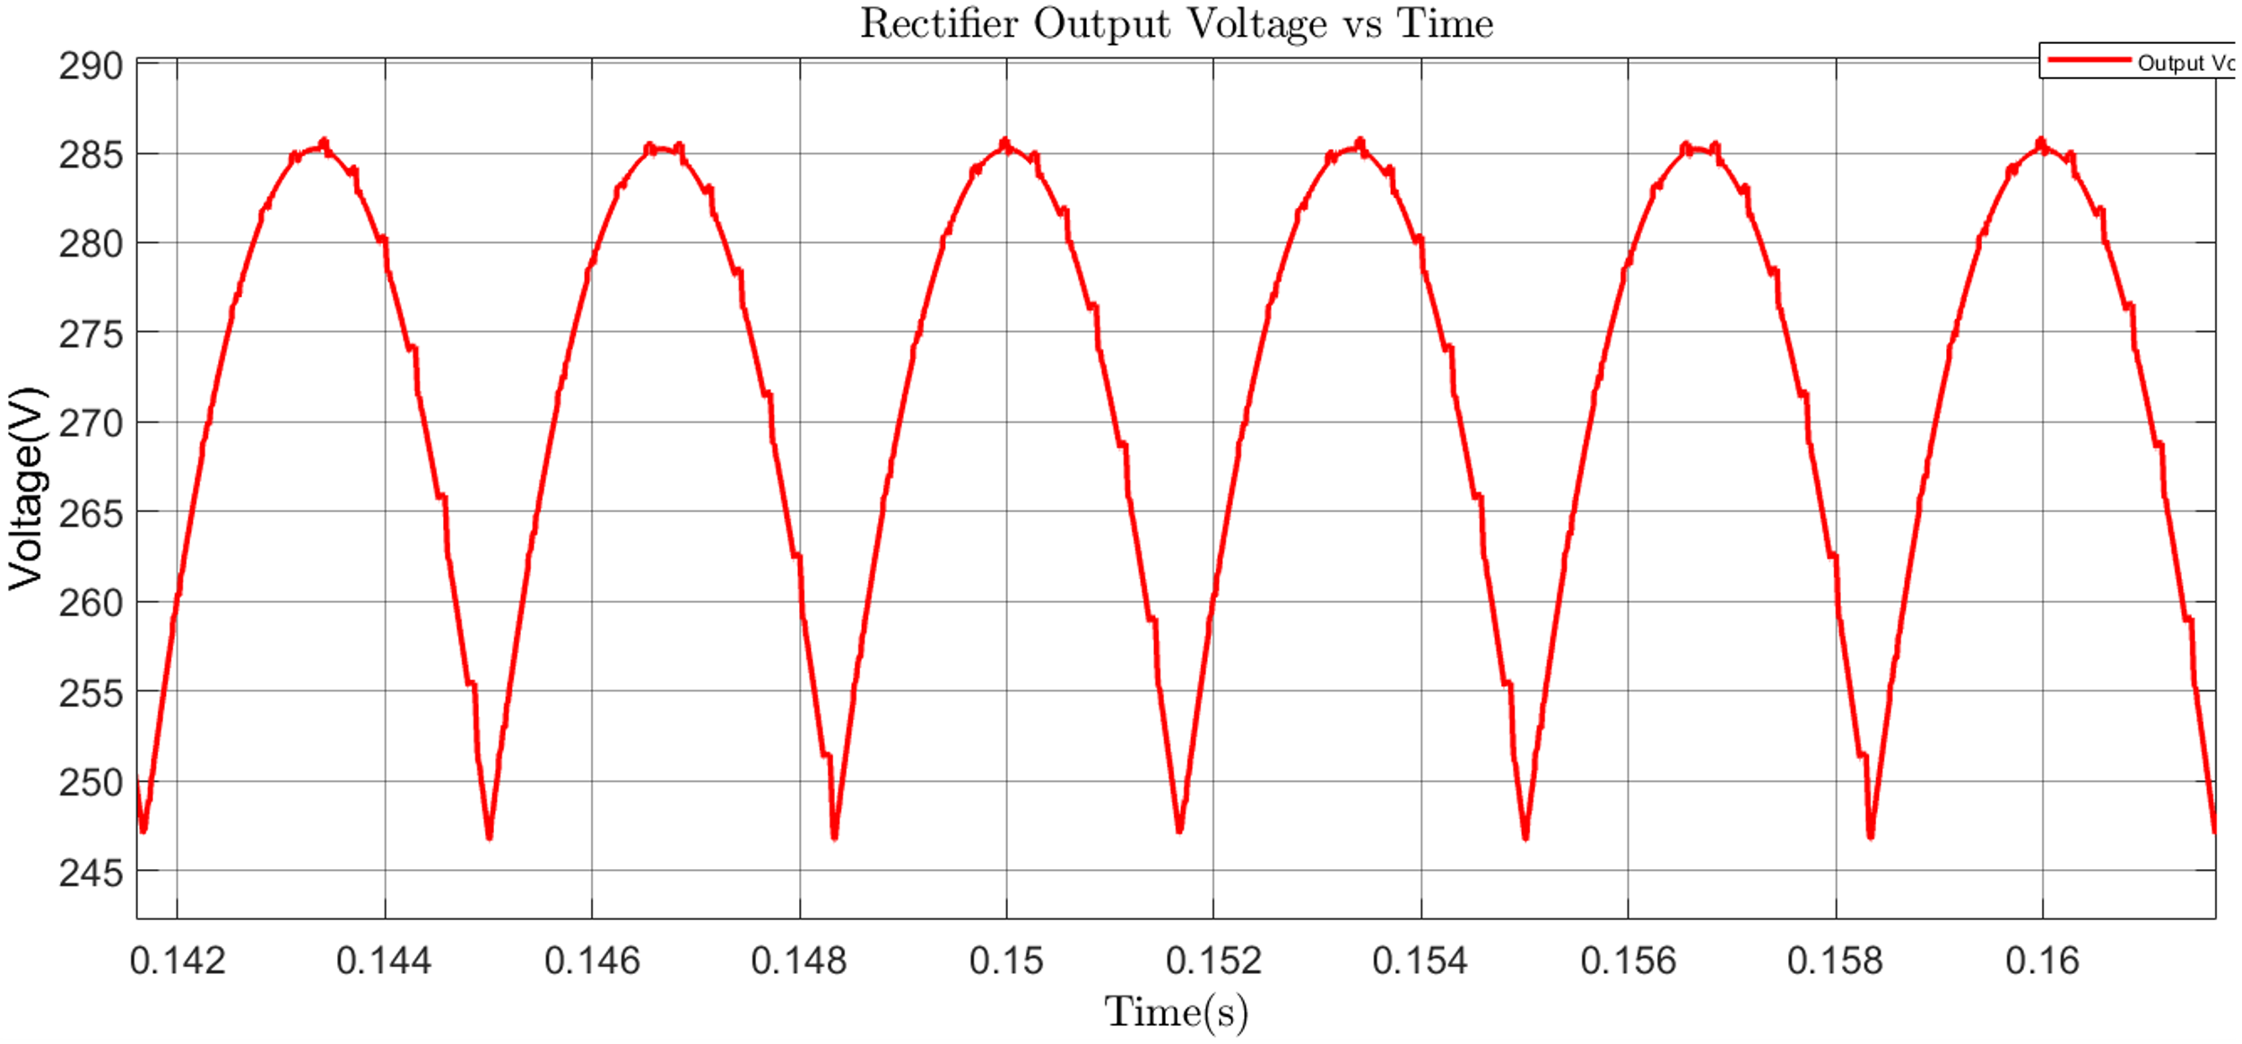

*Figure 5.6 : NONIDEAL CASE Rectifier Circuit Output Voltage vs Time*

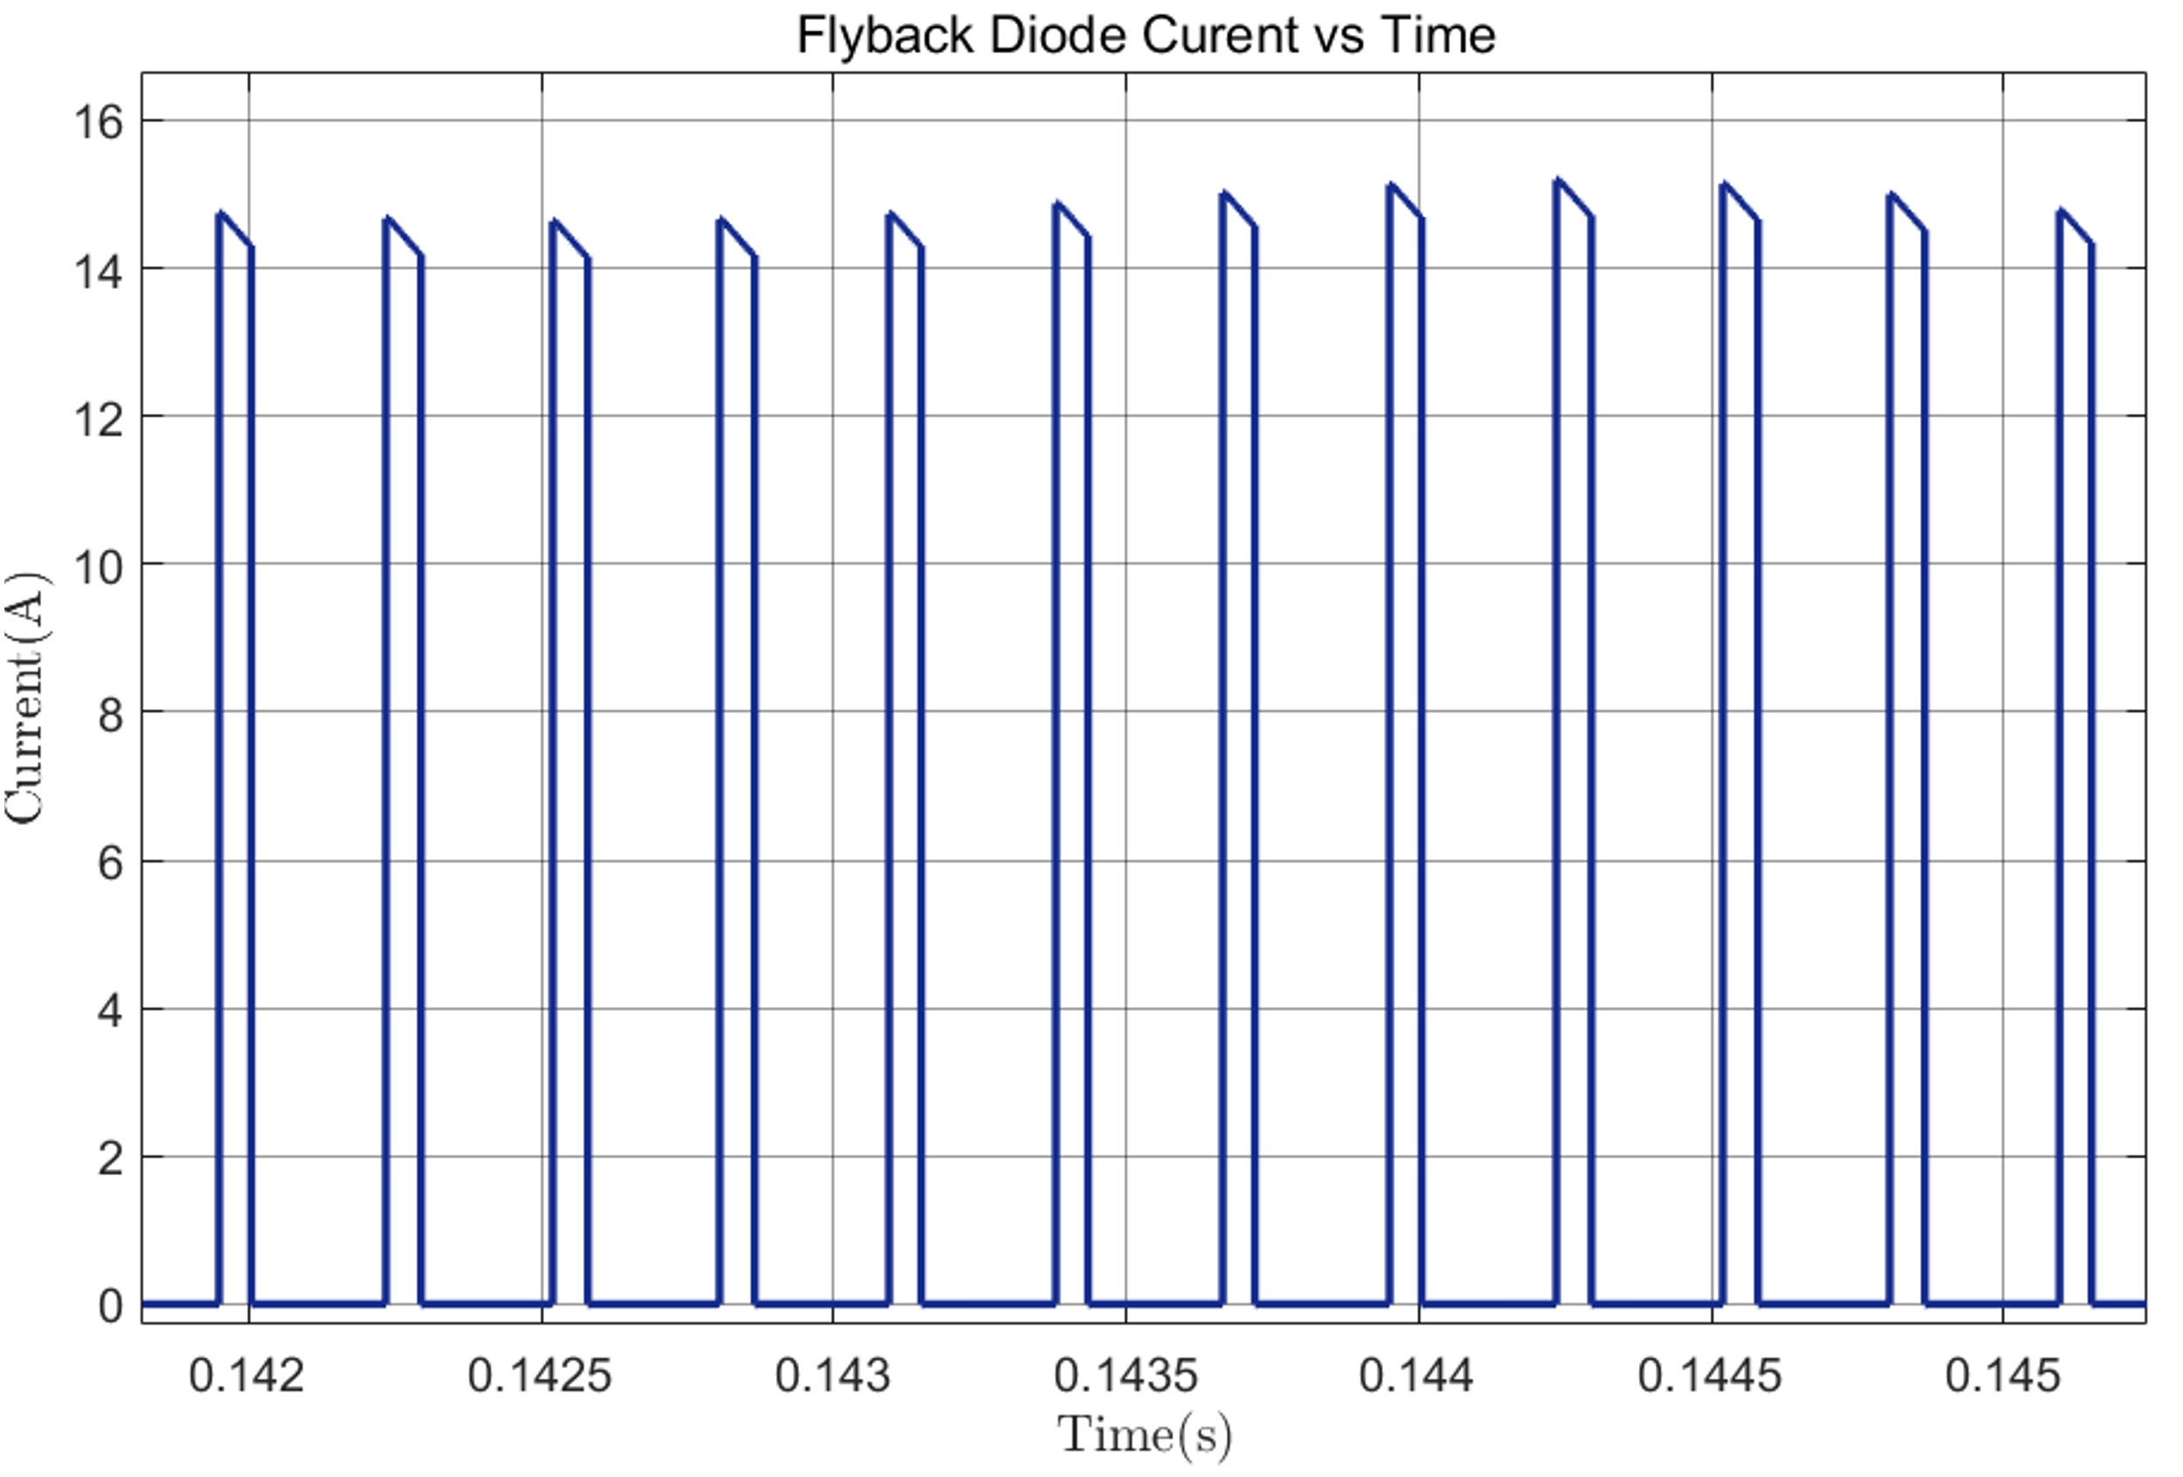

*Figure 5.7 : NONIDEAL CASE Current Through Buck Converter Flyback Diode vs Time*

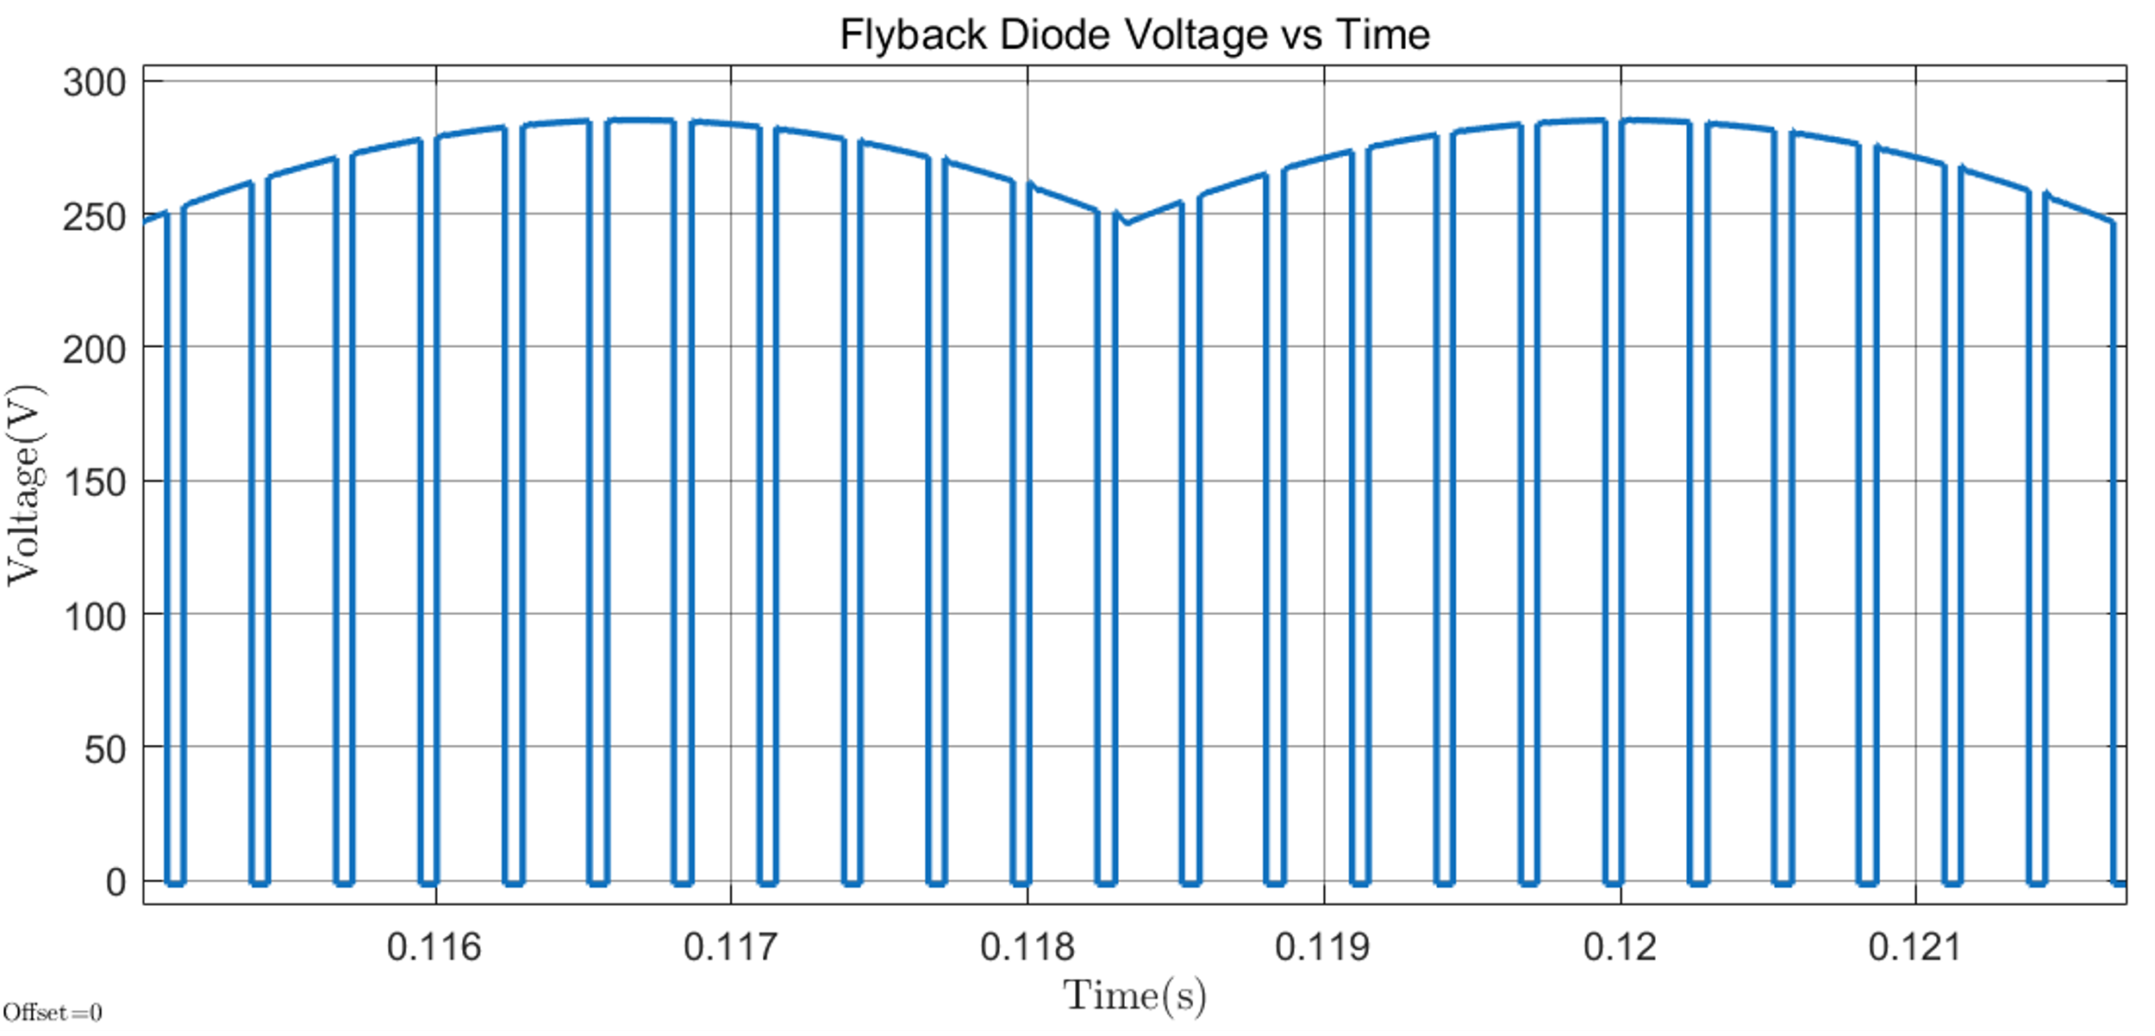

*Figure 5.8 : NONIDEAL CASE Voltage Across Buck Converter Flyback Diode vs Time*

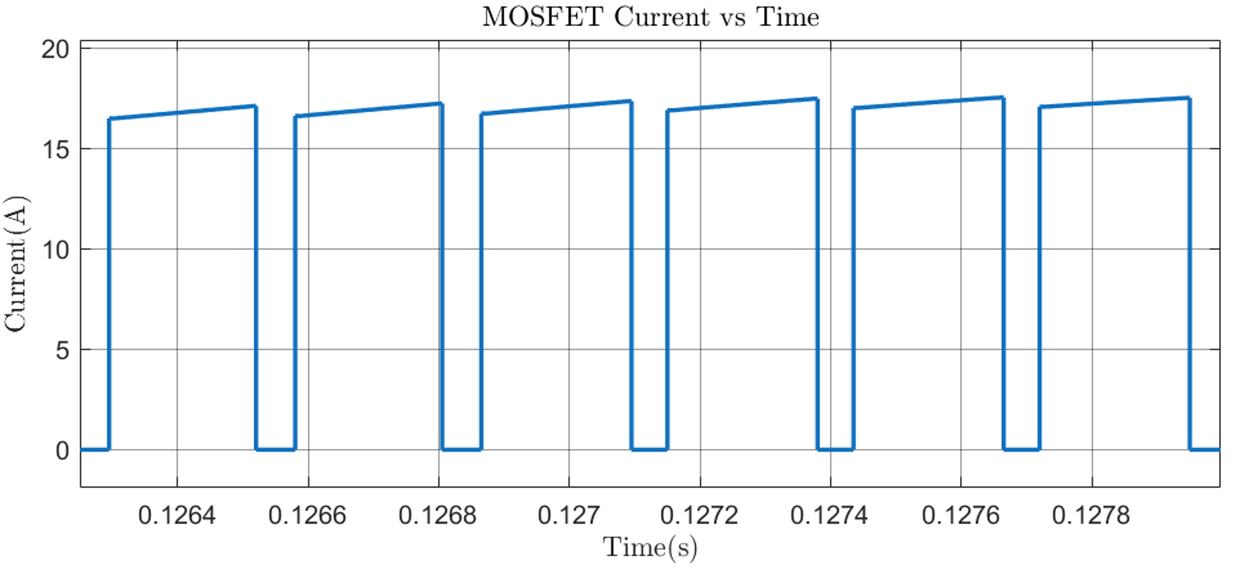

*Figure 5.9 : NONIDEAL CASE Current Passing Through Mosfet/IGBT vs Time*

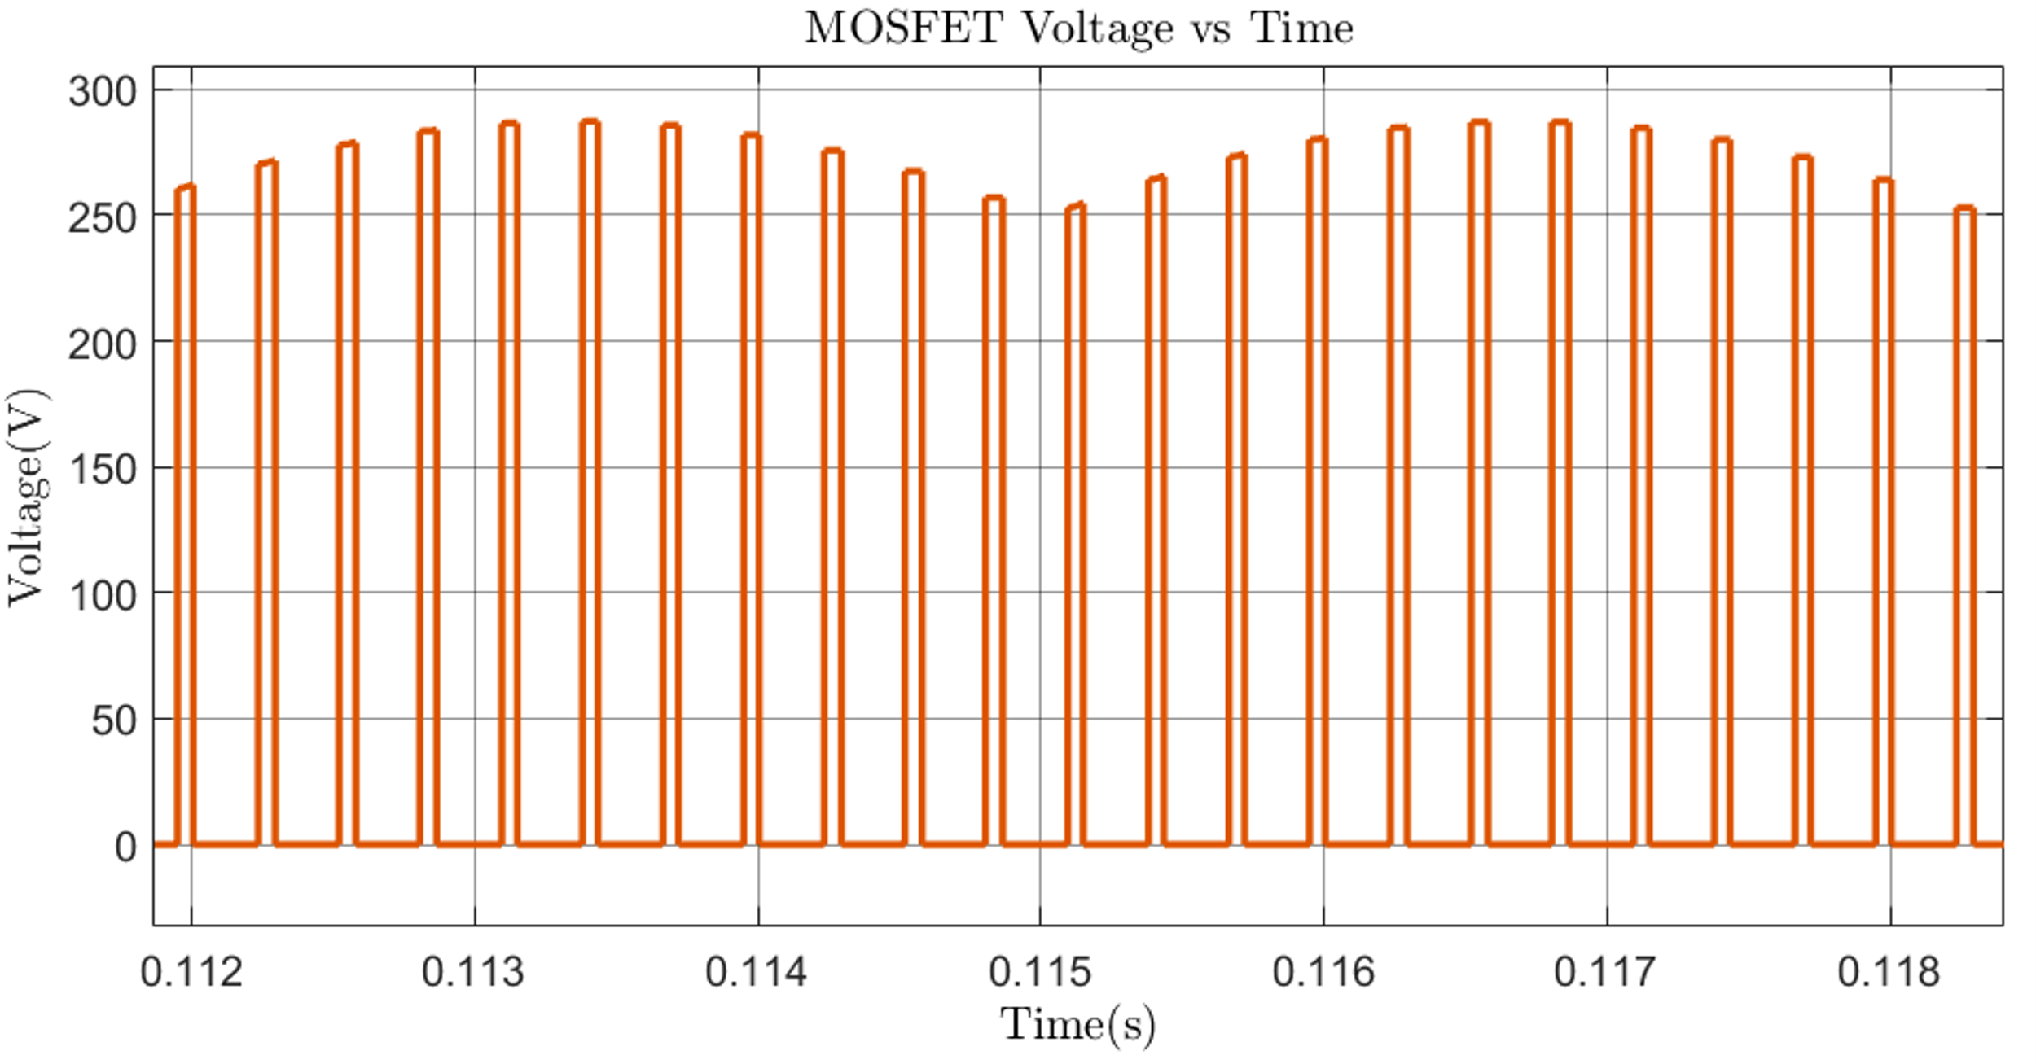

*Figure 5.10 : NONIDEAL CASE Voltage Across MOSFET/IGBT vs Time*

## Controller Simulation and Design

In this section, simulation of a PI-controller is conducted on Simulink. The closed-loop control system given in the Figure 6.1 below, ensures the motor's speed remains stable and responsive to desired changes, even under varying load conditions. Thus, the speed control of the motor will be implemented as armature current controller since the linear relationship between speed and armature current will be assumed. Note that, the controller architecture implemented in PCB design and simulated in Simulink environment have same principles, both utilizes PI controller.

### 6.a Controller Simulation

The controller senses the armature current by the sensor, and error is calculated by subtracting the sense from the set value. Simulink ideal PI controller adjusts the duty cycle according to the error signal and regulates the speed of the motor. The Simulink block diagram of the controller is given below in Fig. x. As mentioned above, this controller is utilized have set current value at the armature of the motor. The simplified feedback diagram can be seen in Fig. xx

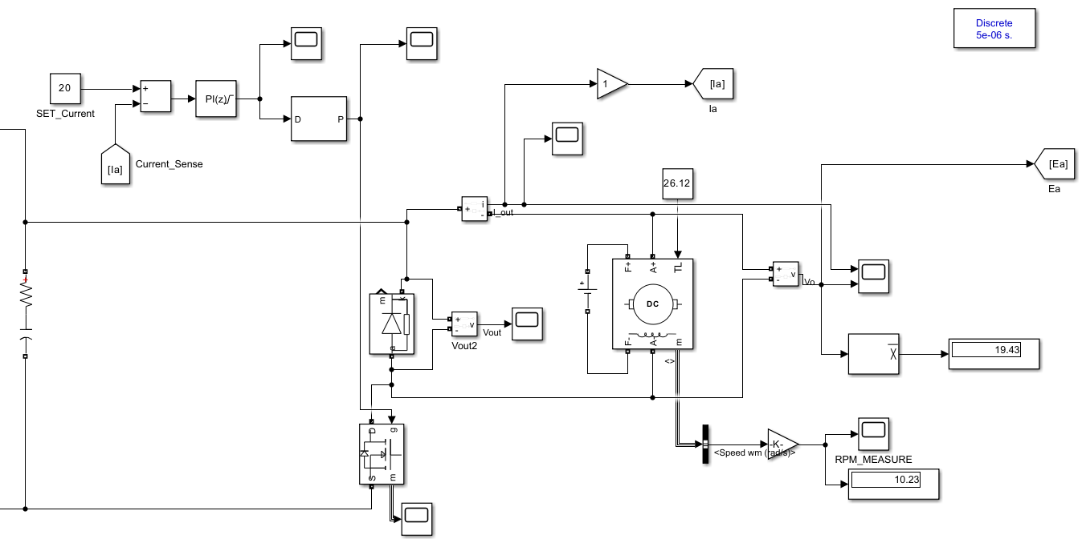

Figure 6.1: Simulink Controller Implementation

Figure 6.2: Simplified Feedback Loop

The performance of the PI controller implemented in simulation environment are given in following figures. In these cases, armature current set values are adjusted to different values (24 A and 14 A) for the manually tuned Kp and KI values. As can be seen from plots, we have almost zero steady state error value thanks to the integral term of the controller. Also, we obtained a RPM speed values when the current value is setted to rated current and we observe that it converges to rated RPM speed of the motor and this response also an evidence of the relation between armature current and motor speed.

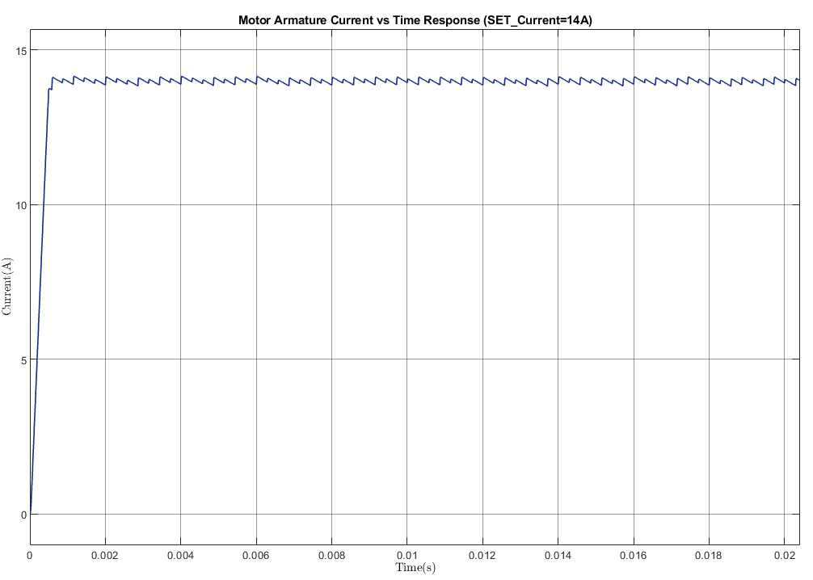

Figure 6.3: Motor Armature Current Response For Set Current is 14A

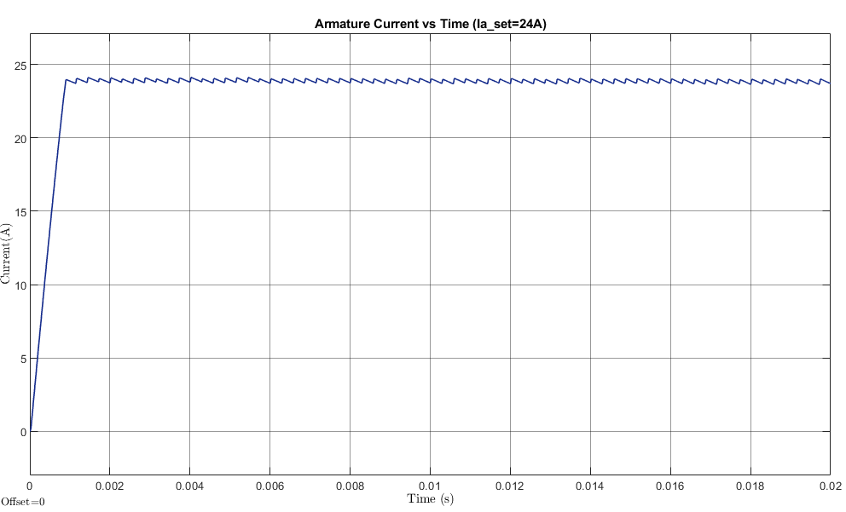

Figure 6.4: Motor Armature Current Response for Set Current is 24A

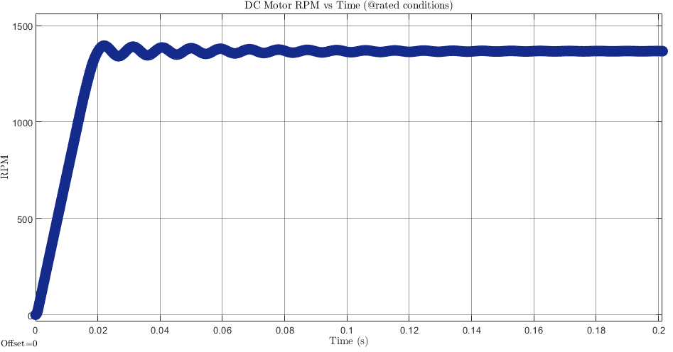

Figure 6.5: Spped (rpm) vs Time Plot

### 6.b Controller Design for PCB

For implementing our controller in the real world, we needed to introduce some new components to the system. First of all, it was necessary to sense the armature current to generate the error signal required for the control loop. In most applications, a very small resistance, commonly known as a current sense resistor or shunt resistor, is used for this purpose. However, this method can lead to power losses and heating, and most importantly may also introduce noise into the measurement. To have proper controller which allows to have minimal steady state error, we decided to use an integrated sensor for current sensing. After evaluating different types of current sensing technologies, we chose the Allegro Hall-effect sensor (*ACS37002*) due to its high accuracy, and reliability. This sensor allows for efficient and precise current measurement without the drawbacks associated with traditional shunt resistors, making it a more robust choice for our application.

The functional block diagram of this sensor is given below. It can be seen that it has lots of different functionalities like overcurrent detection or gain selection. However, to simplify our task, we will not use extra features instead only use the hall-effect measurement block. When current passes through the pins of this device, the analogue measurement signal will be transmitted to the controller. In this implementation, the PI controller is utilized with the help of a special microcontroller. Initially, it was planned to use Arduino Uno for this purpose due to its ease of use and different peripherals. However, then, we wanted to have all of our components on the PCB and use a all-in-one microcontroller. When we checked the commonly used ICs in motor controller we saw an application uses *PIC16F1614* microcontroller to control the speed of the motor. Then, we chose this microcontroller since it perfectly matches with our application. This microcontroller comes equipped with features that align well with the requirements of a PI controller-based motor speed control system. For instance, it has a high-performance 10-bit architecture, built-in peripherals for motor control, and support for pulse-width modulation (PWM), which is essential for adjusting motor speed.

Figure 6.6: ACS37002 Functional Block Diagram

The internal programmable PID controller module of this microcontroller is utilized and generated duty cycle is transmitted to isolated gate driver. The purpose of this gate driver before the IGBT is to provide proper isolation and amplification for the control signals transmitted to the Insulated Gate Bipolar Transistor (IGBT). The gate driver ensures that the low-power signals generated by the microcontroller's PID controller module are converted into high-power signals capable of effectively switching the IGBT. To sum up, our controller architecture involves the sensor measures the armature current, the microcontroller calculates the error signal and apply PI controller operations to this error, and the gate of the IGBT of buck converter which is our plant model in this implementation.

## PCB Design

One of the most critical parts of this project is designing a printed circuit board with a CAD tool. For this purpose, we used Altium Designer since it is a useful and powerful CAD tool specifically designed for professional PCB design and development. In Altium Designer, we created both schematic and layout files, also rendered 3D visuals. While designing schematic and layout of the circuit, there were different considerations we should take. In this section, we will not explain whole procedure of PCB design we did. Instead, the important points we have consider and our observations are provided. The schematic, layout and 3D visual of the designed PCB are given in below figures. The final dimension of the PCB is 11.4 x 17.16 cm. This PCB is designed as four layer board since a this approach offers significant advantages for. The additional layers allow for better signal integrity, improved thermal management, and optimized routing for power and ground planes. Since this implementation was the first PCB design of all of our group members, routing procedure was a bit challenging while we are trying to implement it with two layers. However, as the layer of the PCB is increased, the price for purchasing it will also dramatically increase but in this software design project, we simply ignored the budgeting issues. The first two layers (top layer and first layer) are used as power layers which consists of the traces part of rectifier and buck converter. Also, the supply traces for the integrated circuits in gate driver and controller components are located in these two layers. Since most of the traces we have in this category, we chose two layers for powers. Third layer is designated for the high frequency signals, namely gate signals for IGBT. The layer located at the bottom of the board is used as the whole ground layer.

Figure 7.1: PCB Layer Stack Manager

The choices for the PCB layers are also critical for signal integrity. For example, by having a large ground layer at the bottom of the board, as it provides a low-impedance return path for signals. In addition, this large conducting plate allow to board dissipate heat efficiently. The reason for having a high frequency signal layer in the middle of a PCB stack-up is to improve signal integrity by shielding it between two planes (ground and powers). This arrangement minimizes electromagnetic interference by isolating the signal layer from external noise sources and reducing radiated emissions. This arrangement can be also considered as shielding gate signals by two copper plate up and bottom. Additionally, we considered these EMI and EMC issues while designing the layout of the board. As can be seen from the layout figures below, the components and traces of high power and low power side of the circuits tried to be separated. The reason for that is high power components and circuits generate significant noise and switching transients that can interfere with the operation of sensitive low-power circuits even if they are not located at the same layer.

Another critical issue is the width of the traces used in PCB. In this Rectifier+Converter topology, we have different values of currents flowing at different sides of the board. Thus, it is not possible to use same width of traces for these different currents since use the same width of traces for these different currents since the trace width determines the current carrying capacity of the PCB without overheating or excessive voltage drop. High current paths require wider traces to handle the increased current flow and maintain thermal stability, while low current paths can use narrower traces to optimize board space. To determine these width values, we used the tool provided at the Altium.com website. In this online tool, you can obtain the minimum required trace width by giving the current values and PCB parameters as input. The user interface of this tool can be seen in the figure below.

Figure 7.2: Trace Width Calculator

Figure 7.3: PCB Schematic

Input Connectors

Input Connectors

Controller and Gate Driver

Alm. Capacitors

Freewheeling Diode

IGBT

Bridge Rectifier

Film Capacitor

Figure 7.4: Top Face of PCB

Figure 7.5: Right Orthognal Face of PCB

Figure 7.6: Left Orthognal Face of PCB

## 8 . Bills of Material

|  |  |  |  |  |  |  |
| --- | --- | --- | --- | --- | --- | --- |
| **Name** | **Description** | **Designator** | **Quantity** | **Manufacturer** | **Manufacturer Part Number** | **Price** |
| VUO36-16NO8 | Bridge Rectifier | BR1 | 1 | IXYS | VUO36-16NO8 | $14.97 |
| CL10B104KB8NNNC | Capacitor | C1 | 1 | Samsung Electro-Mechanics | CL10B104K Manufacturer Part Number 1  B8NNNC | $0.10 |
| B43547A9107M000 | Capacitor Polarised | C2, C3 | 2 | EPCOS - TDK Electronics | B43547 | $6.08 |
| GRM188C80G106KE47D | Capacitor | C4 | 1 | Murata Electronics | GRM188C80G106KE47 | $0.17 |
| 06032A101FAT2A | Capacitor | C5 | 1 | KYOCERA AVX | 06032A101FAT2A | $0,64 |
| 06033C393KAT2A | Capacitor | C6 | 1 | KYOCERA AVX | 06033C393KAT2A | $0.31 |
| C4AEGBW6100A3NJ | Capacitor | C7 | 1 | KEMET | C4AEGBW6100A3NJ | $35.16 |
| DSEI30-06A | Diode | D1 | 1 | IXYS | DSEI30-06A | $5.03 |
| ACS37002KMABTR-050B5-00 | Integrated Circuit | IC1 | 1 | Allegro MicroSystems | ACS37002 | $4.86 |
| NCD57085DR2G | Integrated Circuit | IC2 | 1 | onsemi | NCD57085 | $2.70 |
| PIC16F1614-E_ST | Integrated Circuit | IC3 | 1 | Microchip Technology | PIC16(L)F1614/8 | $1.46 |
| M20-9990246 | Connector | J1 | 1 | Harwin Inc. | M20-999 | $0.10 |
| 2MA-02 | Connector | J2, J3, J5 | 3 | TE Connectivity | 2MA-02 | $1,08 |
| G800LR305018EU | Connector | J4 | 1 | Amphenol ICC (Commercial Products) | G800LR | $0.15 |
| IXGH30N60C2D1 | Transistor IGBT | Q1 | 1 | IXYS | TO-247 | $7.94 |
| CR0603-FX-1002GLF | Resistor | R1 | 1 | Bourns Inc. | CR0603 | $0.1 |
| KTR18EZPF2R20 | Resistor | R2 | 1 | Rohm Semiconductor | KTR | $0.23 |

## 9 . Conclusion

The aim of this project was to drive a DC motor with an AC input. In the first phase of the project, we analysed which topology to choose as a team. As a result of our research, single phase diode rectifier+buck converter and three phase diode rectifier+buck converter remained the most suitable ones for the project and for us. Due to the harmonic advantage and other advantages of the three-phase rectifier, our final decision in topology selection was three phase diode rectifier+buck converter. We then performed a series of theoretical operations to determine the parameters of the system. As a result of these theoretical operations, we found the duty ratio and switching frequency values of our system. We performed simulations based on the system values found and determined the components we would use based on the simulation results. After selecting the components, we made power loss calculations to find out whether our power losses were reducing the efficiency of the system or not. According to the values we obtained, we would change the parameters of our system or our components. However, since our power losses were at a reasonable level, we simulated our system to see how our circuit would react in real life, confident in our system parameters and component selections. We gave importance to two things in detailed simulation, firstly, adding the parameters of the components to the simulation environment as much as we could and integrating the parasitic elements into our circuit. We were able to add the component parameters in detail through Simulink and placed the approximate values of the parasitic elements into our circuit as a result of our research and calculations. After adding all the circuit parameters, we simulated the circuit and obtained the voltage and current waveforms of the components. We compared the waveforms we obtained with the results of the simulation we made with ideal values in the first phase of the project. In the comparisons, we observed how non-ideality affects the system. After doing the detailed simulation, we moved on to the controller design, which is another requirement of the project. The controller which we designed effectively regulates the motor's speed by sensing the armature current, calculating the error, and adjusting the duty cycle using a PI controller in Simulink. We tested our controller for set current values (24 A and 14 A) with manually tuned 𝐾𝑝 and 𝐾𝑖, the system achieves near-zero steady-state error thanks to the integral term. Lastly, we designed a printed circuit board (PCB) in Altium Designer by using the components chosen according to test results. The EMI and EMC issues are considered while designing both layout and schematic.